**Practical No -2**

**Design and Develop SQL DDL statements which demonstrate the use of SQL objects such as Table, View, Index, Sequence, Synonym. Design at least 10 SQL queries for suitable database application using SQL DML statements: Insert, Select, Update, Delete with operators, functions and set operators**

**Table**-

CREATE TABLE ACC1(

ACC_NO NUMBER(10),

B_NAME VARCHAR(20),

BALANCE NUMBER(20),

PRIMARY KEY(ACC_NO)

);

-------------

insert into acc1 values(100,'ABC',909090);

insert into acc1 values(1056,'dfg',67090);

insert into acc1 values(103,'CBI',13574);

-------------

**Index-**

**create-**

CREATE INDEX ACC2 ON ACC1(B_NAME);

------------

**View**-

create view v1

as select ACC_NO,B_NAME,BALANCE from ACC1;

--------------------

insert into v1 values(101,'SBI',1000);

-------------------

desc v1;

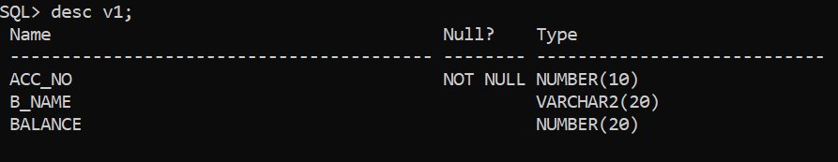

--------------------

**Sequence**-

create sequence acc_seq

start with 10

increment by 1

minvalue 5

maxvalue 50

nocache

cycle;

-------------------

insert into acc1 values(acc_seq.nextval,'abc',563432);

Select * from acc1;

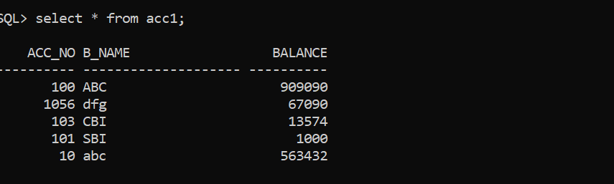

===============================

**DDL Queries- Create,Alter,Drop,Truncate,Desc,Rename;**

**alter-**

alter table acc1 add email varchar(30);

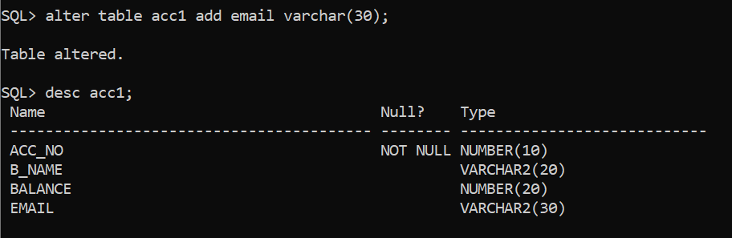

alter table acc1 drop column email;

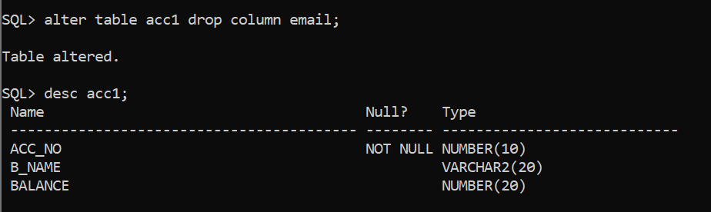

**drop**-

drop table acc1;

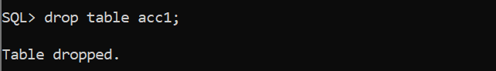

**truncate**-

truncate table acc1;

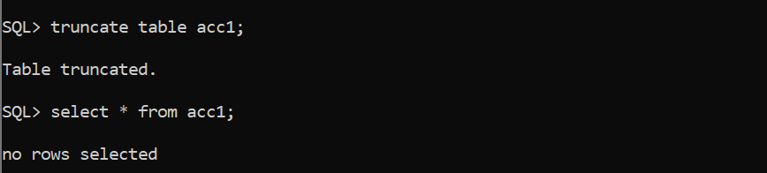

**desc**-

desc acc1;

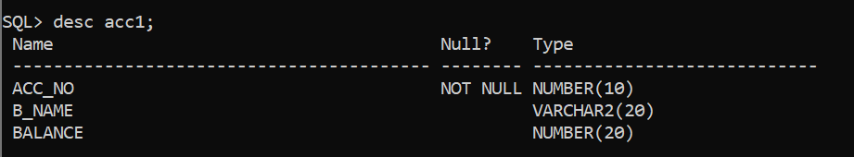

**rename**-

rename acc1 to account1;

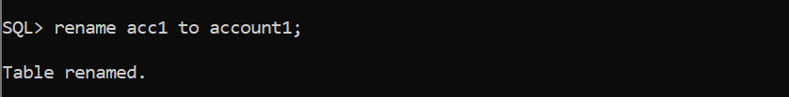

===============================

**DML Queries- Insert,Delete,Update,Select;**

**insert-**

insert into acc1 values(101,'abc',325467);

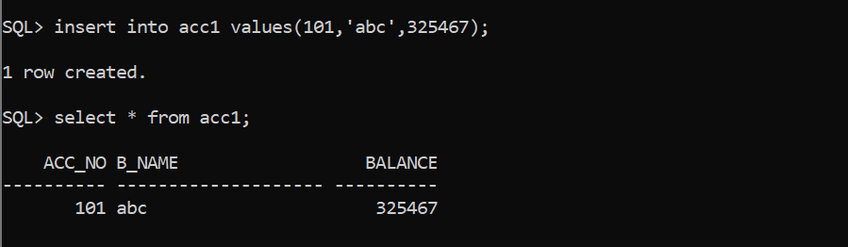

**delete**-

delete from acc1 where acc_no=101;

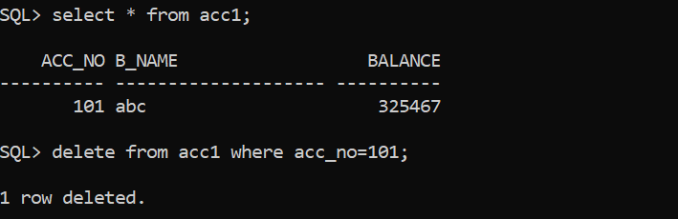

**update**-

update acc1 set balance=90000 where acc_no=101;

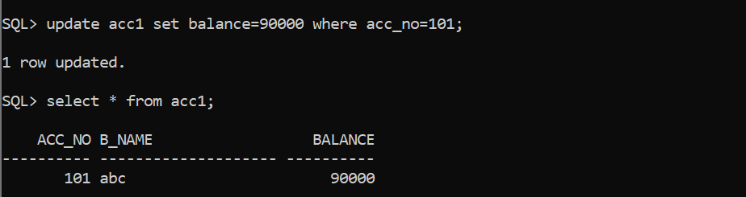

**select**-

select * from acc1;

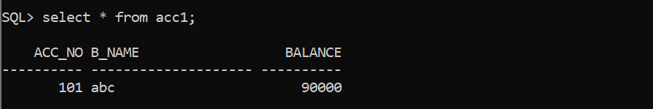

select balance from acc1 where acc_no=101;



